**DELIVERABLE - 1**

GROUP DETAILS

PROJECT TITLE: **Q & A Website**

TEAM NAME: **Techno8**

LIST OF TEAM MEMBERS:

DEEPTHI POTHINENI 11517847

BINDU JAMMULA      11518173

KEERTHI CHINTA 11521499

SAISREE GUMMADI 11438604

VISHWANATH REDDY RAMAYYAGARI 11494863

SURVI VIDIT DATTA 11518176

CHANIKYA DEVARAPALLI 11520751

SHIRIDI CHAITANYA SANDHYALA 11505780

# PROJECT DESCRIPTION:

We are planning to develop a Question and Answer Website which connects the individual minds through questions. It includes features as follows:

1) User has to create an account for signup and the same would be stored in the database.

2) If the user already exists, Login is required.

3) Login helps user to post their doubts, Questions and even the views that are running

in their minds as well to share their knowledge on the present trending topics like Top news, Technologies,

Entertainment, Health, Education etc.

4) User can edit the profile if in case any wrong information is provided during the signup.

5) Posts can be shared through Twitter and Facebook and can be discussed about the same.

6) Add requests can be sent to connect people and look through their posts.

7) User can post their creative content which resembles the blog, Upload the images and Addon would be uploading the videos.

8) Implement Search Engine where the user can search for People and also search the content according to their interest.

9) Adding pagination would divide content into discrete pages, thus presenting content in a limited and digestible manner

without making it clumsy.

10) Using Site Maps to crawl on the browser like Google and Yahoo.

WEBSITE FLOW:

1. Account Creation/ Registration
2. Login
3. Home Page
4. Posting a Question/ Post/ Image/ Doubt
5. Edit and Delete Posts
6. Comment on Posts
7. Search for Posts
8. Profile Page
9. Logout

TECHNOLOGIES USED:

**Frontend** : Html, CSS, Java Script and Bootstrap

**Backend** : MySQL, PHP Server Side Code

**Platform** : Linux Server - Big rock

# INITIAL PROJECT PLAN:

|  |  |  |
| --- | --- | --- |
| Task | Start Date | Days to Complete |
| Requirement Gathering | 3-Sep | 7 |
| UI - REGISTRATION, LOGIN | 10-Sep | 7 |
| UI – HOME PAGE | 17-Sep | 7 |
| DATA MODEL CREATION | 10-Sep | 14 |
| UI - PROFILE PAGE | 24-Sep | 7 |
| DATABASE USER DATA LINKING | 1-Oct | 7 |
| UI – QUESTION POSTING PAGE | 8-Oct | 7 |
| UI – COMMENTS POSTING PAGE | 1-Oct | 14 |
| DATABASE QUESTIONS, COMMENTS AND USERS LINK TO DATABASE | 15-Oct | 14 |
| TESTING PHASE - I | 15-Oct | 7 |
| BUG FIXING AND DELETION OF QUESTIONS FUNCTIONALITY | 22-Oct | 7 |
| FINAL TESTING | 29-Oct | 4 |
| BUG FIXING-RISK MANAGEMENT | 3-Nov | 5 |
| RE-EVALUATION | 9-Nov | 3 |
| PRESENTATION & FINAL DOCUMENTATION | 12-Nov | 4 |

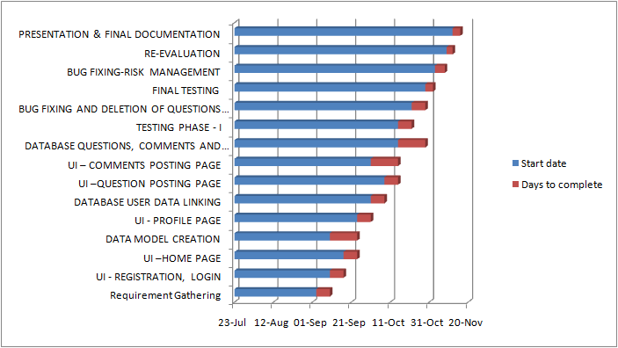

# MINUTES OF MEETING:

Session 1

Date : 28Th August 2021

Attendees:

DEEPTHI POTHINENI 11517847

BINDU JAMMULA      11518173

KEERTHI CHINTA 11521499

SAISREE GUMMADI 11438604

VISHWANATH REDDY RAMAYYAGARI 11494863

SURVI VIDIT DATTA 11518176

CHANIKYA DEVARAPALLI 11520751

SHIRIDI CHAITANYA SANDHYALA 11505780

Discussion:

* Introduction among ourselves and our technical skills.
* Discussed about what we are good at.
* Contributions to the previous projects which would help us plan our project.
* Shared Project Ideas.

Session 2

Date : 4Th September 2021

Attendees:

DEEPTHI POTHINENI 11517847

BINDU JAMMULA      11518173

KEERTHI CHINTA 11521499

SAISREE GUMMADI 11438604

VISHWANATH REDDY RAMAYYAGARI 11494863

SURVI VIDIT DATTA 11518176

CHANIKYA DEVARAPALLI 11520751

SHIRIDI CHAITANYA SANDHYALA 11505780

Discussion:

* Finalized our Project Idea as Question and Answer Website from various thoughts.
* Discussed features that can be included in the website.
* Discussed and picked technologies that everyone could cope up with.
* Distributed the work among ourselves based on the plan.

# RISK MANAGEMENT:

Plans to monitor the risks:

* Testing at every phase of development as an end user.
* Trying few techniques to check if the passwords of test data are getting Encrypted.

Re-evaluation of risks:

* After fixing the bugs that occurred at the end of every phase, we will be re-evaluating them before starting new phase.

Contingency plans for the risks:

* Testing would be done considering every possible scenarios(risks) that could occur.

Risks that might occur:

1. Encrypting the password by using Special Characters would enhance the security of User Credentials.
2. Adding Session Timeouts and handling SQL Injection Errors.
3. Few of the glitches which needs to be handled by the developer : Specified Authors can only Edit or Delete the posts.

The above risks will be taken into consideration and handled in further phases.

TEAM MEMBER ROLES:

DEEPTHI POTHINENI - Backend Developer, Documentation

BINDU JAMMULA      - Requirement Gathering, Testing

KEERTHI CHINTA - UI Developer, Documentation

SAISREE GUMMADI - UI Developer, Presentation

VISHWANATH REDDY RAMAYYAGARI - Database, Documentation

SURVI VIDIT DATTA - Backend Developer, Presentation

CHANIKYA DEVARAPALLI - Backend Developer, Testing

SHIRIDI CHAITANYA SANDHYALA - Database, UI Developer

MEMBER CONTRIBUTION TABLE:

|  |  |  |  |
| --- | --- | --- | --- |
| Member name | Contribution description | Overall Contribution (%) | Note  (if applicable) |
| DEEPTHI POTHINENI | Backend Developer, Documentation | 20% |  |
| BINDU JAMMULA | Requirement Gathering, Testing | 20% |  |
| KEERTHI CHINTA | UI Developer, Documentation | 20% |  |
| SAISREE GUMMADI | UI Developer, Presentation | 20% |  |
| VISHWANATH REDDY RAMAYYAGARI | Database, Documentation | 20% |  |
| SURVI VIDIT DATTA | Backend Developer, Presentation | 20% |  |
| CHANIKYA DEVARAPALLI | Backend Developer, Testing | 20% |  |
| SHIRIDI CHAITANYA SANDHYALA | Database, UI Developer | 20% |  |